**Golden Chalet**

**7225 Ryan Gulch Rd. Silver Queen West, Silverthorne, CO 80498**

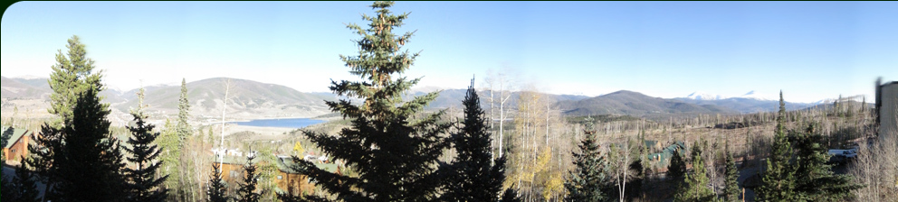

The address is above, but online mapping websites may not put you right in front. The proper location is here

<http://maps.google.com/maps?q=39.618844,-106.091784&num=1&t=h&sll=39.619144,-106.091259&sspn=0.007,0.010139&ie=UTF8&ll=39.61877,-106.091945&spn=0.00175,0.002535&z=19>

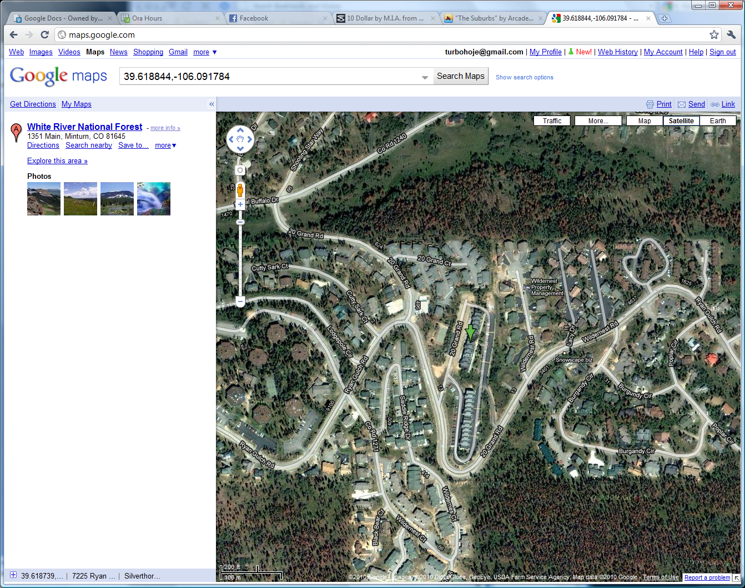

As you pull into Silver Queen West, we are building C. From the lot the building looks like this.

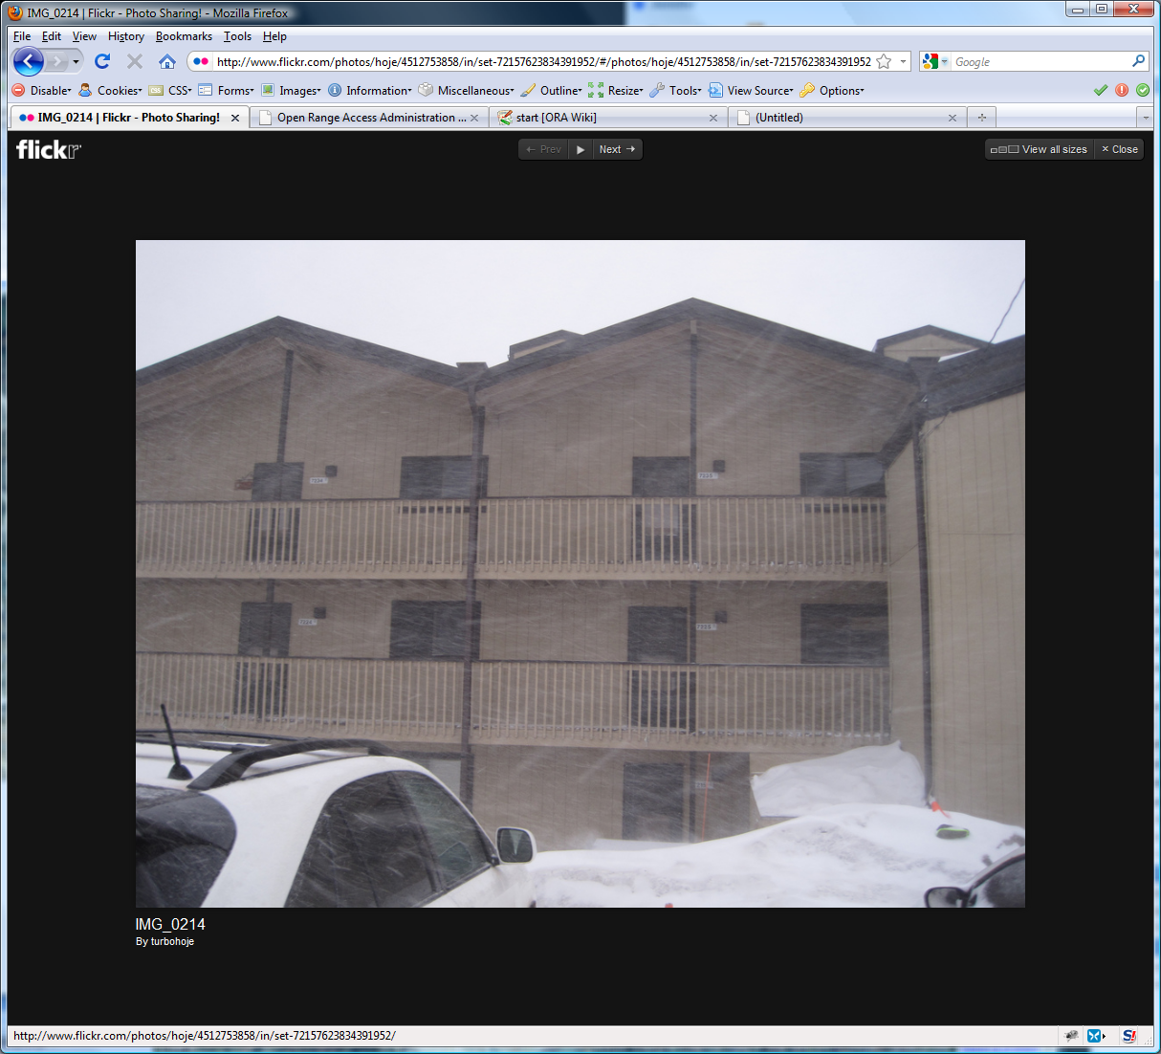

This is it!

Park anywhere out front, it is not assigned. If you have a diesel or have a block heater; there is an outdoor plug on the south end of the garages.

# Door Lock

**Always check and ensure that the door has latched completely and that the dead bolt fully engages by testing the door.**

**Unlock**:

Mash in your code, spin it to the right. If it is dark, the Schlage button on the top will backlight them for easier mashing.

**Lock**:

Push the “Schlage” button on the top and spin the handle to the left. The handle will disengage electronically after a few seconds.

# Places to Eat

By no means is this all, but this is some of our regulars.

**Sunshine Café**

([http://sunshine-cafe.com](http://sunshine-cafe.com/))

This is our favorite place for breakfast. They have great food and coffee, however it comes at a price. There is always a wait and its awesomeness is no secret. Sunshine is often the warm bosom you need to lay your pounding head in after a rowdy night of drinking. Get a banana nut muffin, it will make love to your mouth.

**Blue Moon Deli**

(<http://www.bluemoonbakery.net/>)

There is not much room to eat here, but they make good sandwiches. Breakfast burritos are good, but large to eat on your own before skiing. They are like the mountain equivalent of an Einstein’s or something. Also there is a liquor store next door you can pick up a bottle of champagne, and get some OJ here to make mimosas pre-skiing or while you wait for a table at sunshine.

**Red Mountain Grill**

(<http://www.redmountaingrill.com/>)

Great Food, good pizzas.

**Dam Brewery**

(<http://www.dambrewery.com/>)

Bar food, but more where the après-ski drinking scene is at

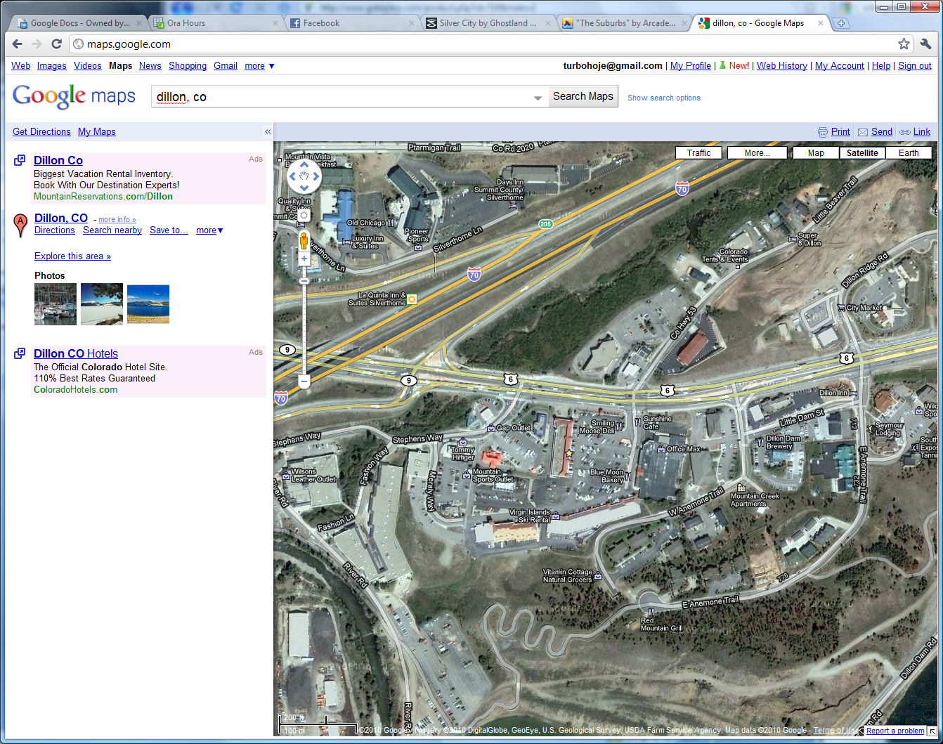

Sunshine Blue Moon Damn Brewry Red Mtn

# Heat

There is a thermostat on the wall, the heat is water base board.

There are fans in both bedrooms.

# Trash

There is a dumpster on the north side of the garages that are across from the front door. It has a bear-lock on it that consists of a cable pulled over a bolt. If you find it locked, please lock it again. Feeding the bears after midnight makes bear-gremlins and we don’t want that again.

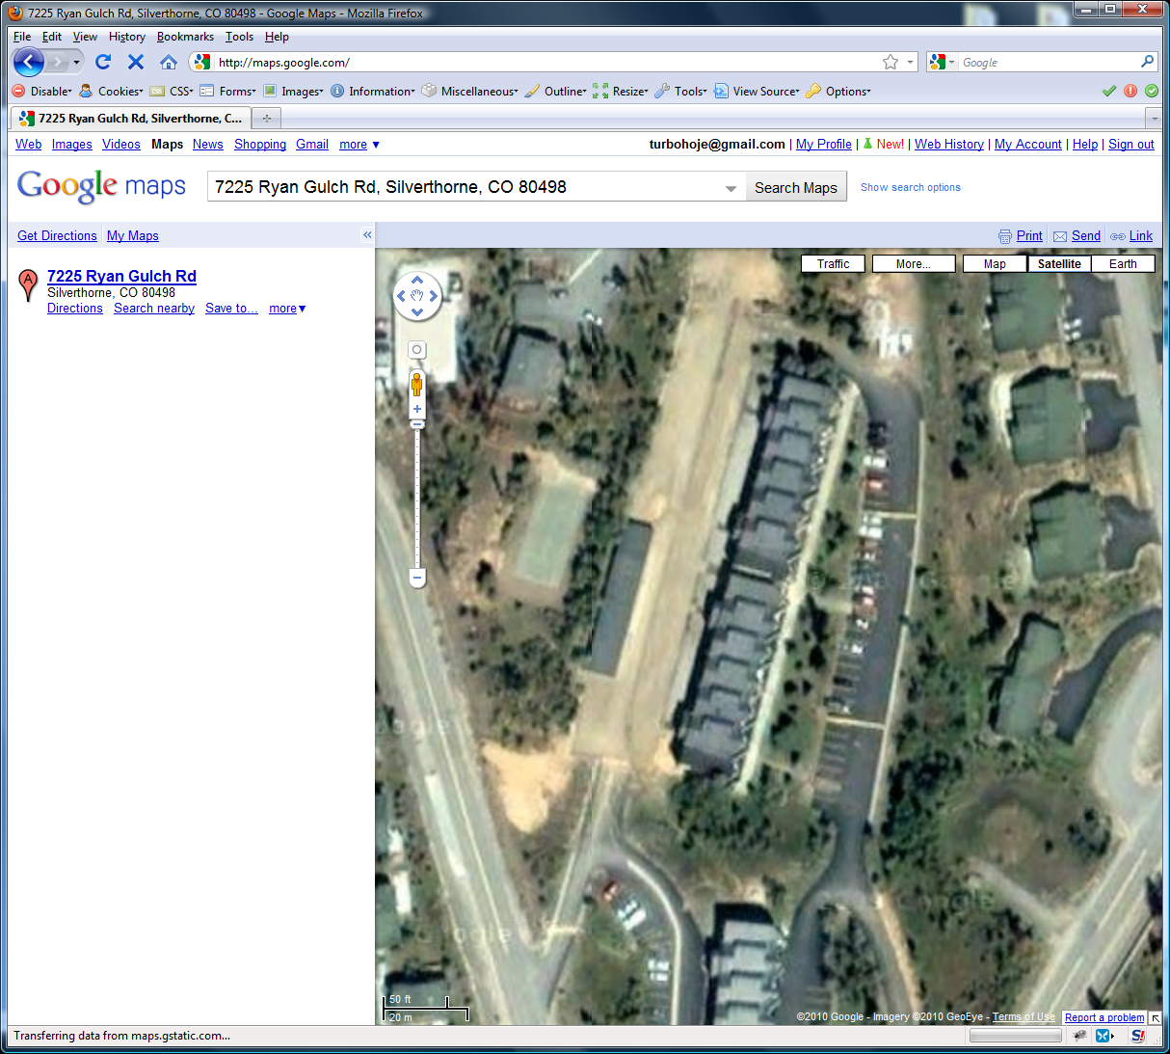

Condo

Dumpster

# TVs

There is a PS3 mounted on the wall behind the TV in the living room. The cable box and the internet router is there as well.

If you are unfamiliar with Playstations, you can turn them on with either remote by pressing the big circular “PS” button. The TV must be on HDMI input, and the rest is fairly straight forward. If a remote doesn’t work, press its PS button as it may need to be

The TV in the master bedroom has a chromecast. You can “cast” to this by installing the google home app and connecting to the wifi network. Then use the apps like Netflix/Hulu et al on your smart phone to control content.

# Summit Stage Bus

The summit stage bus stop is right across the street from silver queen west. It comes every 30 minutes. More information can be found here: <http://www.summitstage.com/>

We have only ridden it once. It took us 70 minutes from the time we got on the bus to make it to keystone with the bus switch and all the stops. It’s really easy to ride and or figure out, but isn’t the fastest.

# Internet

NETGEAR60

Luckyraccoon585

# Other

Please do not smoke indoors or bring animals.

# Fires

Fires are not allowed without expressed written permission and evaluated on a case-by-case basis.

# Contacts

**Jennifer**

303-570-3873

**Justin**

303-669-3787